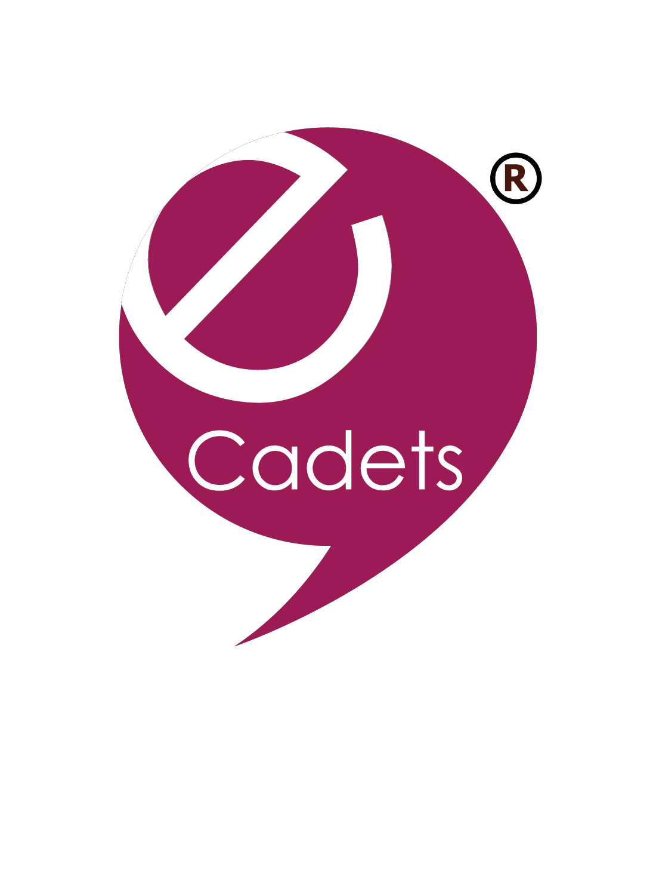

eCadets is a pupil led online safety education programme.

Led by the pupils, they act as the peer mentors who train their classmates through a series of curriculum based activities. There are three activities per term (only one is mandatory) and they take approximately 20 minutes to complete.

The lesson plans are all written for the eCadets and once the work is completed it is sent back to us. We mark it all and you get a results page breaking down the progress of your school overall by year, class and child. You are able to assess how every individual child at your school is progressing against the eSafety strand of the computing curriculum and receive an inspection ready report - Ofsted inspection teams love us!

The programme provides an instant messenger facility called ‘Ask Henry’ which supports the eCadets in answering any questions or queries they may have, whether that be from pupils or teachers.

All pupils have full access (not just eCadets), the programme gives them all a safe platform which is fully moderated by us to converse with each other within the same year group via an application called GoBubble.

The programme saves teachers 24 days planning time a year, as all of the work is done for them. It successfully empowers the pupils as the programme is pupil-led and gives the Heads the reassurance that eSafety is being delivered effectively, whilst developing their pupils; the feedback of the impact at schools is unreal.

The programme starts at 3yrs (Mini eCadets), 7yrs+ (Primary eCadets) through to 18yrs (Senior eCadets). It is a 6-year programme, although schools only activate per academic year (there is no commitment thereafter to continue). Schools can use their Pupil Premium budgets as well as other funding if required (and we provide the content for them to
support this).

Attached a video link from another eCadet school so you can hear from pupils as well as the Head Teacher and Co-Ordinator of the programme;
https://youtu.be/lPkKEZD5GWo

If you are looking to activate your eCadet programme before the end of term you will
receive KS1 Mini eCadets for free (saving your school £250).

Simply use code LEWBEE and click here to receive both KS1 and KS2 programmes for just
£600 or reply to this email to say ‘Yes. Please activate my eCadet programme’ along with the
name and postcode of your school and we will do the rest.

If you need more information feel free to visit www.ecadet.zone or email Sarah direct at
sarah@ecadets.co.uk or myself Deb Lewis at deb@lewbee-d.co.uk .

Sarah Wren Relationship Manager sarah@ecadets.co.uk
01244 893281
eCadets Ltd

